2011 Regional Rally Results
Rally was held at the CNHP grounds. A big thank you to all the volunteers. Here are the results.
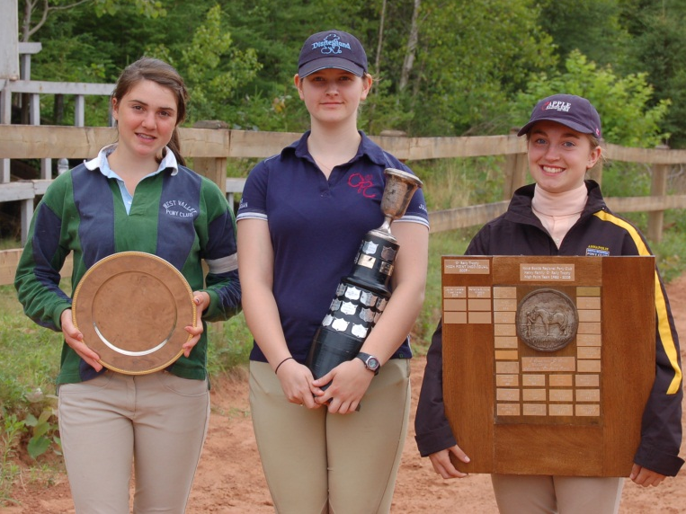
INDIVIDUAL
TRAINING DRESSAGE AND OVERALL( BOTH RESULTS THE SAME)
1ST JULIA LOCKE- OPP-WINNER OF DONALD GRANT TROPHY
2ND DAMITA HANSEN-ANN
PRE-TRAINING DRESSAGE AND OVERALL ( SAME PLACINGS FOR BOTH)
1ST EMILY BALTZER-WV- TROPHY WINNER
2ND LIANNA JACQUARD-WV
3RD EMMA FOOTE-ANN
4TH MIRANDA BEVERIDGE-ANN
5TH CHANTAL PAUPIN-TANT
6TH MELISSA WILE-OPP
STARTER DRESSAGE OVERALL
1ST SAMANTHA SYMONDS -ANN SAMANTHA SYMONDS- ANN-HENRY FAMILY TROPHY WINNER
2ND DELANEY MACKENZIE-ANN DELANEY MACKENZIE-ANN
3RD HAYLEIGH STEWART-OPP JOECY PETERS- OPP
4TH HANNAH FOOTE- ANN HANNAH GERTRIDGE-ANN
5TH JOECY PETERS- OPP EMMA MARQUIS- OPP
6TH HANNAH GERTRIDGE- ANN REBECCA DODSWORTH-LUSH- OPP
TEAM STABLE MANAGEMENT AND OVERALL ( SAME PLACINGS FOR BOTH)
1ST ANNAPOLIS #1
2ND WEST VALLEY/ TANTRAMAR
3RD ANNAPOLIS #2
4TH OPPORTUNITY # 2
5TH OPPORTUNITY #1

